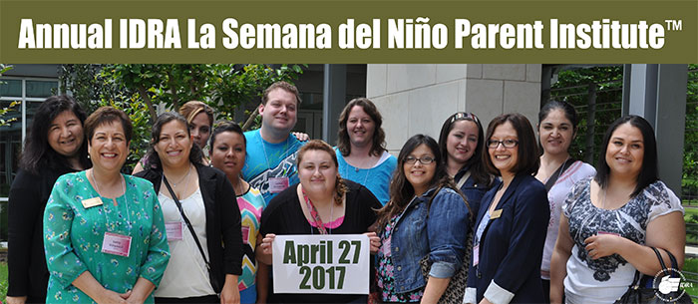

Bilingual Parent Institute
Special event for families, community groups, educators and administrators

Thursday, April 27, 2017
Whitley Theological Center • 285 Oblate Drive, San Antonio • 9:00 a.m. to 2:00 p.m.
The fee is $60 per person (includes presentations, materials, exhibits, refreshments and lunch).
Register online at budurl.com/IDRApiRegC or use the form below.

Name:
Position/Title:
School & District:
Community Organization:
Mailing Address:
City: |  |  |  |  |  |  | State, Zip
Phone: |  |  |  |  |  |  | Cell:
Fax:
Email:
Total Enclosed: |  |  |  |  | Check or PO#

Mail registration form with a check or purchase order to the address below OR Fax purchase order to IDRA at 210-444-1714 OR Email purchase order to IDRA at contact@idra.org. Make checks payable to: Intercultural Development Research Association. Purchase order numbers may be used to reserve space. Full payment prior to the institute is expected. If you have more than one registrant, please use a separate registration form(s) or email a list with names and their contact info to contact@idra.org.

Photography Notice
Please be aware that by participating in IDRA events, you are automatically authorizing the Intercultural Development Research Association (IDRA) and its employees, agents and personnel who are acting on behalf of IDRA to use your name, photograph, video image, voice or other likeness for purposes related to the mission of IDRA, including but not limited to publicity, marketing, websites other electronic forms or media and promotion of IDRA and its various programs.
