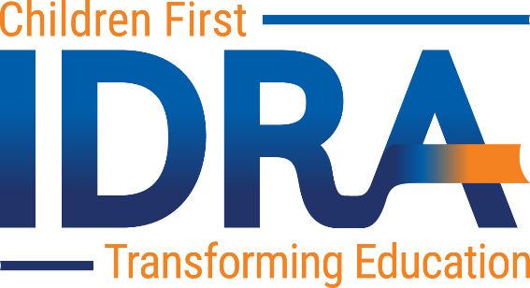

IDRA José A. Cárdenas School Finance Fellows Program
Application Form

Contact information
Name: |  | Mailing Address
Date: |  | City, State, Zip:
Email: |  | Phone:
Institutional or Organizational Affiliation:
Current Position/Title:

Background
Attach your curriculum vita reflecting related experience, research and publications (limited to three pages in length).

Research Description
Attach a description of your proposed research (up to seven pages). Include the following information.
- Detailed description of the topic to be addressed and its significance in the area of school finance reform.
- The uniqueness or originality of the proposed effort.
- The project’s key research question and related hypotheses. (Note the research must address one of the key research questions posed in the Call for Applications or provide compelling evidence for a variance from those options.)
- Methodology, including key activities, timelines and techniques to be used to analyze data collected.
- Brief overview of relevant literature in the area to be examined.
- Relevance of the inquiry to contemporary school finance policy deliberations.
- Timelines for data collection, analyses and research completion.
- Budget of up to $20,000 to include research expenses, cost of release time, travel and IDRA one-month residency. (IDRA will provide office space during the residency.)

Letters of Recommendation
Attach three letters of recommendation from parties familiar with you and your academic experience.

