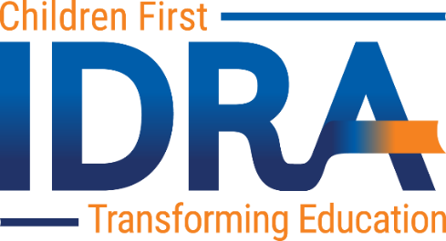

IDRA Education Policy Fellows Program
Application Form
See Call for Fellows for program details and eligibility requirements.

Contact information
Name: |  | Mailing Address
Date: |  | City, State, Zip:
Email: |  | Phone:
Institutional or Organizational Affiliation:
Current Position/Title:

Background
Attach a cover letter and your curriculum vita or resumé.

Application Questions
Attach your answers to the following questions (up to 500 words each).
- What is educational equity?
- How and with whom have you worked for educational equity in your personal and/or professional life?
- What do you hope to gain from this fellowship program?
- What do you hope to give to this fellowship program?
- How will you pursue educational equity in your career?

References
Attach two references, one from a previous supervisor or employer and another from a previous or current colleague or collaborator.

Application Packet submission
Submit your application materials by email to Terrence Wilson, J.D., at terrence.wilson@idra.org by September 30, 2021, at 11:59 PM CST.

